**1. Introduction**

A resume, or résumé is an essential tool to present one’s background, skill sets and accomplishments for job applications. However, when it comes to resume screening, an employer or a recruiter normally takes on average 8 to 10 seconds to screen resumes before shortlisting candidates for pre-screening interviews. Hence, an impressive and well-written professional resume is important to make a good first impression to potential employers (Roo, 2015). Nevertheless, resume writing is a challenge for fresh graduates and most of them tend to make mistakes (Mustafa, 2018), ending up producing a poorly-formatted and unprofessional resume. Moreover, some job seekers who have broad portfolios with numerous achievements, certifications, and project details would want to attempt the “one-size-fits-all” approach, which resulted in a lengthy resume.

With the advent of the Web, an easier way for building resumes is using the existing online resume generator such as NovoResume and Rezumizer. This project intended to enhance the existing systems and user experience by proposing a web-based resume generator with augmented reality (AR) features, known as AResume. It is for job applicants who have difficulty in creating a professional resume from scratch, as well as trying to attempt a “one-size-fits-all” approach. The unique feature of this web-based application compared with others is the capability to upload digital media as AR features in order to highlight their achievements, certifications, and other important information. AR is a technology that creates an interactive experience and displays 2D or 3D computer-generated perceptual information that overlays in the real-world environment.

A web AR is implemented in this project instead of mobile AR as it is lightweight, support cross-platform and does not require installation. Moreover, web hosting is required to allow the project to be able to run and the AR scanner is required to run over HTTPS. In this project, PHP, CSS and JavaScript is used in both front-end and back-end development. In addition to that, AR.js and A-Frame are the main web AR frameworks employed. AResume is expected to provide better user experience not only for applicants but also for hiring managers when screening resumes.

**2. Proposed Solution**

The methodology used in this project is Rapid Application Development. It is chosen because it prioritises rapid prototyping and iterative development as well as testing processes. This model will be easier for this project as it will be tested on mobile devices most of the time, and errors found can be fixed during the development phase. Fig. 1 and Fig 2. shows examples of user interfaces for AResume, where a resume is generated with attached QR code and AR marker. The QR code with embedded AR scanner URL and AR marker are attached to the resume by default. When users scan the QR code, users will be redirected to the AR scanner website and AR contents will show up when scanning the marker.

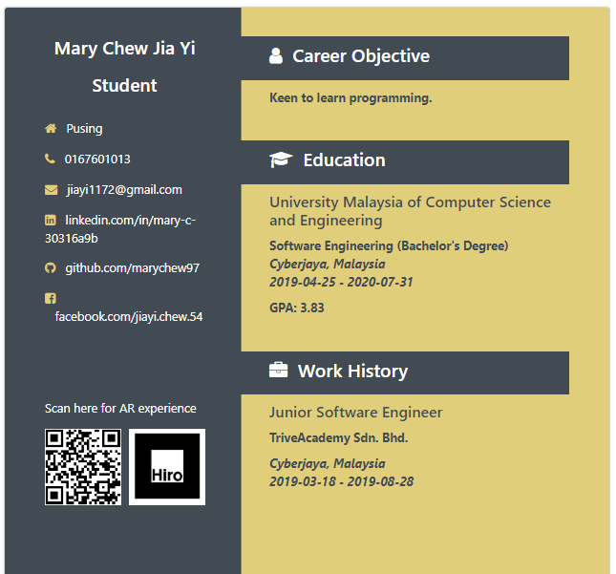

**Fig. 1.** Generated resume with QR code and AR marker being attached

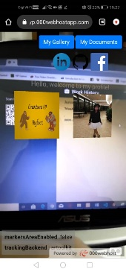

**Fig. 2.** Augmented display on a mobile phone

**3. Conclusion**

Building a resume is tedious work as it includes the processes of drafting, formatting and writing. These processes may lengthen the time needed for creating a professional resume. Currently, there are some ways of building a resume, such as using an online resume generator or using Microsoft Word’s template. However, these kinds of tools could not help to encounter the problems of building a resume, especially when want to leave a good impression of themselves through resume to the hiring managers. This project proposed a web-based resume generator with additional features of AR. It is capable of producing an augmented resume. Resume with AR feature also enhances the attractiveness and interactivity of a resume and enables employers to view all the achievements and certifications of the applicants.

**4. References**

Mustafa, Z. (2018). Writing a resume: Art of your ownself. Retrieved from https://www.nst.com.my/education/2018/

11/429011/writing-resume-art-your-ownself.

Roo, J. (2015). The Importance of a Well Written Professional Resume. Retrieved from https://www.

linkedin.com/pulse/importance-well-written-professional-resume-roo-resumes-judi-roo.